
I-Composition
Write a paragraph that describe a memorable mead :-
...................................................................................................................................
……………………………………………………………………………………...
……………………………………………………………………………………...
……………………………………………………………………………………...
……………………………………………………………………………………...
……………………………………………………………………………………...
……………………………………………………………………………………...
II- Comprehension
Read the following passage and answer the questions below:-
James wants a dog. He walks to the pet store. James sees the animals at the pet store. He sees the cats. He sees the rabbits. He sees the birds. He sees the mice. He sees the dogs
“How much does the dog cost?” James says.
“Twenty dollars,” the man says.
James gives the man twenty dollars. James buys the dog. The dog walks home with James. Now James has a pet. James love his dog so much. He feeds it a lot of meat and burger.
A - Put  or × :
1-James gives the man Ten dollars . ( )
2- James wants a dog . ( )
3-The dog walks home with James. ( )
4 -James buys the rabbit . ( )

B- Choose the correct answer :

1- The man's name in this passage is……………
A-Ahmed B-James c-Albert

2-James wants a ……….
A .dog B. fish c. bird

)1)

3-James sees the ______________ at the pet store.

a-animals b-shoes c-Furniture
4- He sees the ………………….

a-elephants b-cats c- lion
C- Complete the sentences with one of these words:
meat - pet - dollars - burger
1-Now James has a __________________.

2-James gives the man twenty ____________

3- He feeds it a lot of __________and ____________

III-Grammar
A- Choose the right answer :-
1- The school is ( enough / too / also ) big .
2- ( Learns / Learning / Learn ) how to ski is difficult .
3- She gets ( interest / interesting / interested ) of the new book .
4- You must take care ( on / of /in ) your health.
5- Parrots can be ( trained / training / trains ) to talk .
6- This is the funniest joke I have ever ( hearing / hears / heard ) .
B- Do as shown between brackets :-
1- They will clean the room . ( change into passive )
……………………………………………………………………………………...
2- He put on the dress . ( rewrite the sentence in different way )
……………………………………………………………………………………..
C- Correct the mistakes :-
1- It is an American black car .
…………………………………………………………………………
2- Play football after eating is not a good idea .
………………………………………………………………………….
(2)
IV-Vocabulary
A- Match:-
1- guts ___ amazing
2- hang in there ! ___ ready for
3- cool ___ very quickly
4- in no time ___ courage
5- killer ___ Don't give up
6- up for ___ Great !
B- Choose :-
1- pampered means (indulged / puzzled / irritated ) .
2- detectable is the same meaning of ( delicious / interested / astonished ).
3- something that isincrediblecan also be called ( bilingual / astonished / remarkable ).
4- alert means (aware / long / existed )
5- merit is the same meaning of ( amazing / an advantage / developed ) .
6- nurturing means ( afraid / attractive / caring ) .
C- Write the correct picture under the picture :-
parrot /onion / weightlifting / lion

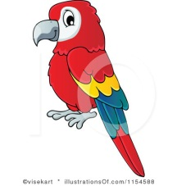
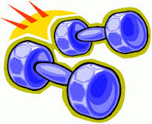

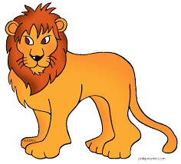

…………….. ………………. ……………… ……………….. …………... …………….. ………………

Good luck…
(3)

